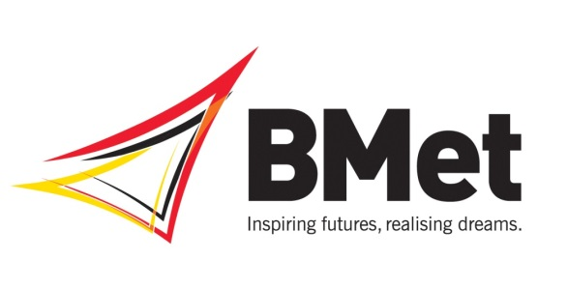
Independent Governor Vacancies
About The College
BMet College is one of the largest further education colleges in the UK, providing a wide range of education, training and apprenticeship courses across the West Midlands
We are made up four colleges; James Watt College in Great Barr, Matthew Boulton College, central Birmingham, Stourbridge College and Sutton Coldfield College. We also have education and training centres serving local communities in Erdington, and Kidderminster. We enrol around 25,000 students of all ages each year on a range of full, part time and higher education courses
We work with local employers and businesses as well global companies including BMW Group, Samsung, Caterpillar, IBM, Jaguar Land Rover and Network Rail to deliver training, apprenticeships and work experience/placement opportunities for students
Our Vision Statement is ‘Inspiring Futures, Realising Dreams’ and we are now seeking additional independent governors to join the Board and help us to achieve this vision.
About the Corporation Board
Our independent Board members are drawn from leaders, or potential leaders from business, public bodies and the third sector. All are motivated by a determination to help our students achieve their potential and ensure that the College is effectively contributing to, and benefitting from, the agenda for economic growth being spearheaded by the Local Enterprise Partnership.
Being an independent governor of the College also offers the opportunity to work with a collegiate Board with a diverse skill set operating in a fast changing environment.
Our Board currently consists of six independent governors, two student and two staff governors and the Principal. The Board meets approximately six times a year and each independent governor is a member of one or more committees. Our committees meet between three and six times a year.
Who we are looking for
Our independent governors are crucial to provide the right balance of support and challenge to our Executive team, and to set the strategic framework for the success of the College. Over the next twelve months, due to pending retirements, the Board has identified a need for up to seven additional independent governors. We are particularly keen on hearing from candidates with significant experience in:
- Business (including SMEs)
- Finance
- Banking
- IT and Digital
- Law
- Academic Leadership
- Property
- Central or local government
We value diversity and welcome applications from all backgrounds. We particularly welcome applications from sections of the community which are currently under represented at the College, including black and ethnic minority groups.
The recruitment process
If you are interested in the opportunity to join a vibrant Board and contribute to a dynamic social business please send your CV in confidence to:liam.nevin@bmetc.ac.uk
The College is a charity and therefore the position is unremunerated, although reasonable expenses will be paid.
Further information is contained in the Governor Role Profile or you can speak in confidence to the Company Secretary, Liam Nevin (liam.nevin@bmetc.ac.uk or telephone 0121 5038508)

